[In Progress] Figure 1: A) Three major river systems in Western Alaska, the Yukon (Blue), Kuskokwim (Red), and Nushagak (Green) river-basins. Icons (will change color, location) indicate sampling locations for samples on each river. B) Sr8786 Isoscape of all three river-basins. Darker Colors indicate more enriched values ( close to .740) whereas lighter values indicate less enriched ( closer to .702).

Figure 2: Model Performance comparison among data sources and model types. Accuracy indicates the proportion of each class correctly classified. F1-Score is the harmonic mean of precision and recall, providing a balanced performance measure across all watershed classes. Results compare two Sr87/86 timeseries smoothing methods (GAM, MA) and three machine learning algorithms (Random Forest, SVM, KNN) using either all test data (Total) or only overlapping isotope ranges (Overlapping). Darker green colors indicate higher scores.

Figure 3: Confusion matrix from the highest performing model (Random Forest on GAM Smoothed data) for both total test set and overlapping subset. Boxes along the horizontal axis indicate correctly classified individuals (red). Vertical axis labels are the actual watershed labels whereas horizontal labels are the predicted class from the model. Percentage labels are the percent of the actual class identified as the predicted class.

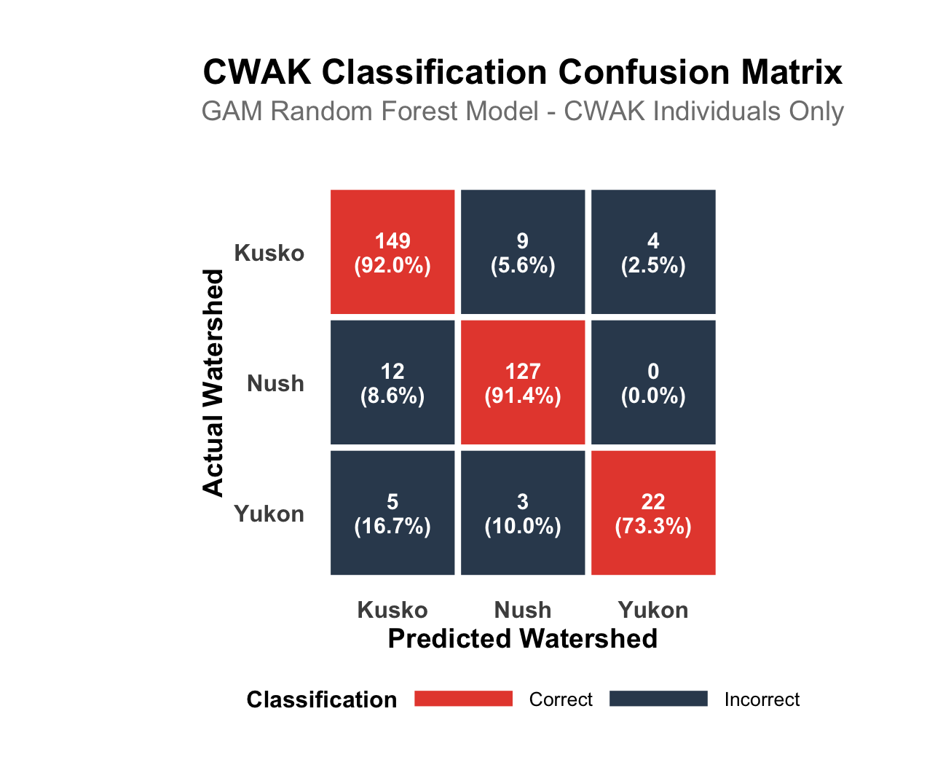

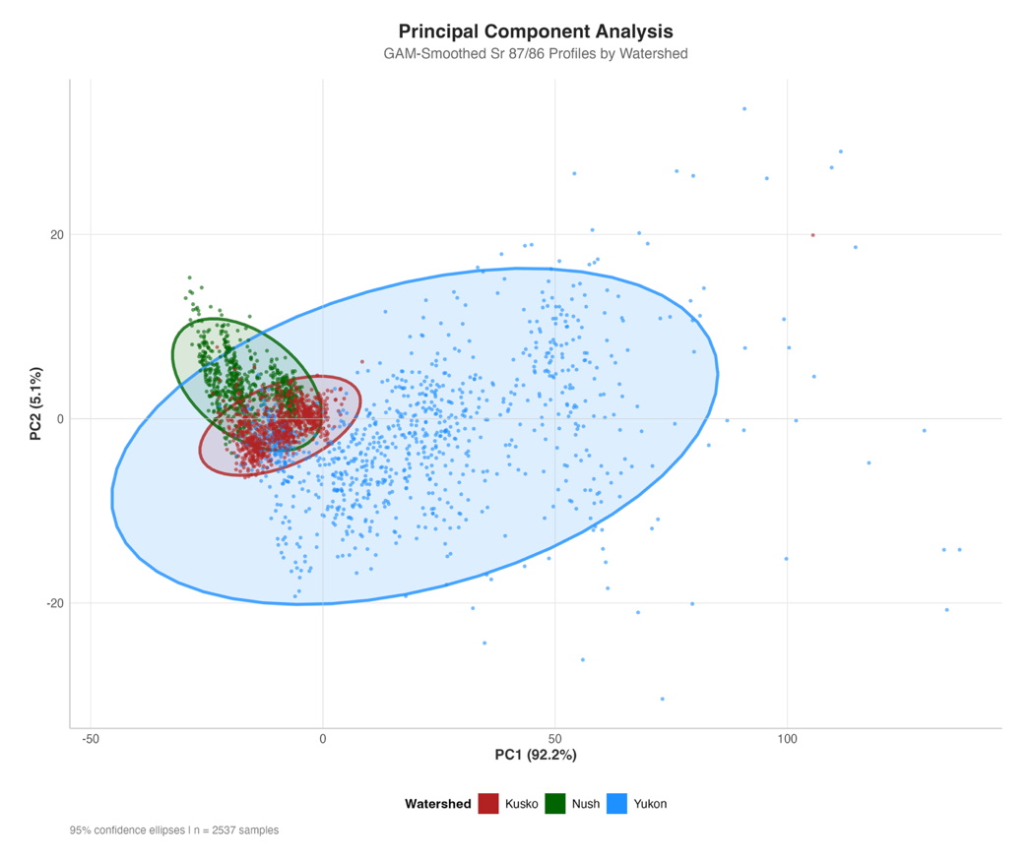
Figure 4: Principal Component analysis of gam smoothed timeseries data (n = 2,531). Significant clustering is evident for all three watersheds, but with overlap between all watersheds. Yukon (Blue points) contain a much larger range of values, indicative of the large range in natal Sr87/86 values in the basin. Kuskokwim (Red points) overlap between both Nushagak and Yukon fish, likely due to its position in the region between both watersheds.

Figure 5: A) Principal component analysis of all samples with a natal origin Sr8786 of 0.708- 0.7085. Clustering among watersheds is evident between principal components 1 and 2 (68.39% of variance), as well as between principal components 2 and 3 (31.16% of variance). There is some overlap between all three watersheds in both cases. B) Sample otolith LA timeseries colored by the absolute value of the PCA loadings at associated timeseries indices. PC1 (top row) shows high loading on the middle section of the timeseries after the natal origin region. PC2 is driven by the region of the timeseries towards the marine entry, likely the result of mainstem migration to the ocean. PC3 is driven by the very beginning of the timeseries, which is the region associated with the natal origin. Yukon individuals from the CWAK region contain a less pronounces mainstem signal as compared to their counterpart from the upper or middle Yukon genetic groups.

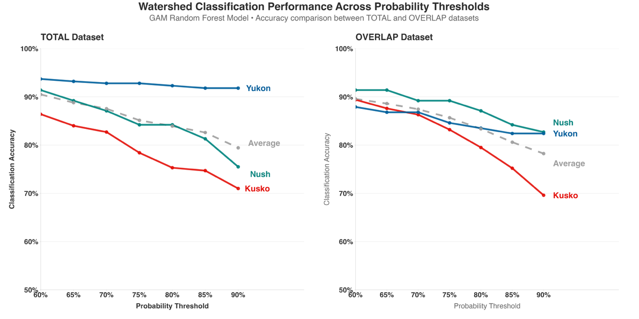
Figure 6: Classification accuracy with an imposed probability threshold (60-90%). Grey dashed lines represent the overall accuracy above the threshold at each point. Colored lines illustrate the class-specific probability at that threshold

